**PAPR Version 1 Spec Notes**

Mark Shepherd 1/12/2021

This document describes all the functionality of the Air-To-All PAPR Firmware, version 1. The description comes from several sources, as follows:

1. This drawing by Sheldon Phillips shows the main features of the UI/UX:
2. 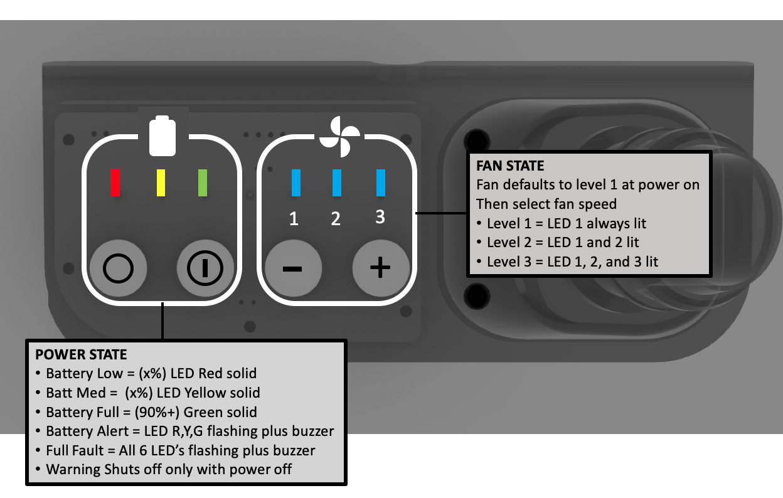The spreadsheet *PQP_P005_PQP_Rev_1B_3_Dec_2020_Rev0.1.xlsx* has some requirements which affect the PAPR firmware:

Section 12 PCB line 64 “Audible Warnings Responsive to Conditions” - Warnings for low battery and low-flow (if applicable) are triggered as input drops at and below specified input levels.

Section 12 PCB line 65 “Command Responses are within Tolerances” - Alarms sound within Db tolerances, alarms deliver correct sound to spec's, shut-on and shut-off responses are within time spec's if specified, etc.

1. The spreadsheet *PAPR_Design_Review_8_June_2020.xlsx*, sheet NIOSH Design Requirements has some requirements which affect the PAPR firmware:

Line 109 - The design must include a low-flow warning. It must actively and readily indicate when flow inside the respiratory inlet covering falls below the minimum air flow defined in §84.175. THIS DOES NOT APPLY to PAPR version 1. See “Additional details” below.

Line 111 - Warning devices must be configured so that they may not be de-energized while the blower is energized.

Line 112 - During use, warning devices must not switch off automatically and must not be capable of being switched off by the wearer.

Line 113 - Any warnings which require different reactions by the wearer must be distinguishable from one another.

1. Additional details:

On power down the PAPR briefly turns on all the LEDs, and sounds the buzzer.

There is a “Fault” LED, situated between the 3rd and 4th LED, that is not shown in the drawing above.

PAPR provides a Low Battery alert and a Fan Speed alert. Currently there is no “Full Fault”.

The Low Battery alert occurs when the battery voltage drops below a critical level. The Fault LED, all 3 battery LEDs, and the buzzer all slowly pulse on and off. During a Low Battery alert, the Fan Up and Fan Down buttons still work normally.

The Fan Speed alert occurs if the fan RPM goes out of the expected range. This could happen, for example, if the airflow is blocked, if the fan malfunctions, etc. The Fault LED, all 3 blue fan speed LEDs, and the buzzer all quickly pulse on and off. During a Fan Speed alert, the Fan Up and Fan Down buttons still work normally, unless the fan itself has malfunctioned.

There is no airflow sensor, therefore no airflow warnings. PAPR will not vary the fan speed to achieve constant airflow. As a result, PAPR version 1 does not meet the N requirements, only HE.

1. Open questions

What are voltage levels for battery low/medium/high?

What are RPM / dutycycle / airflow for fan low/medium/high?